

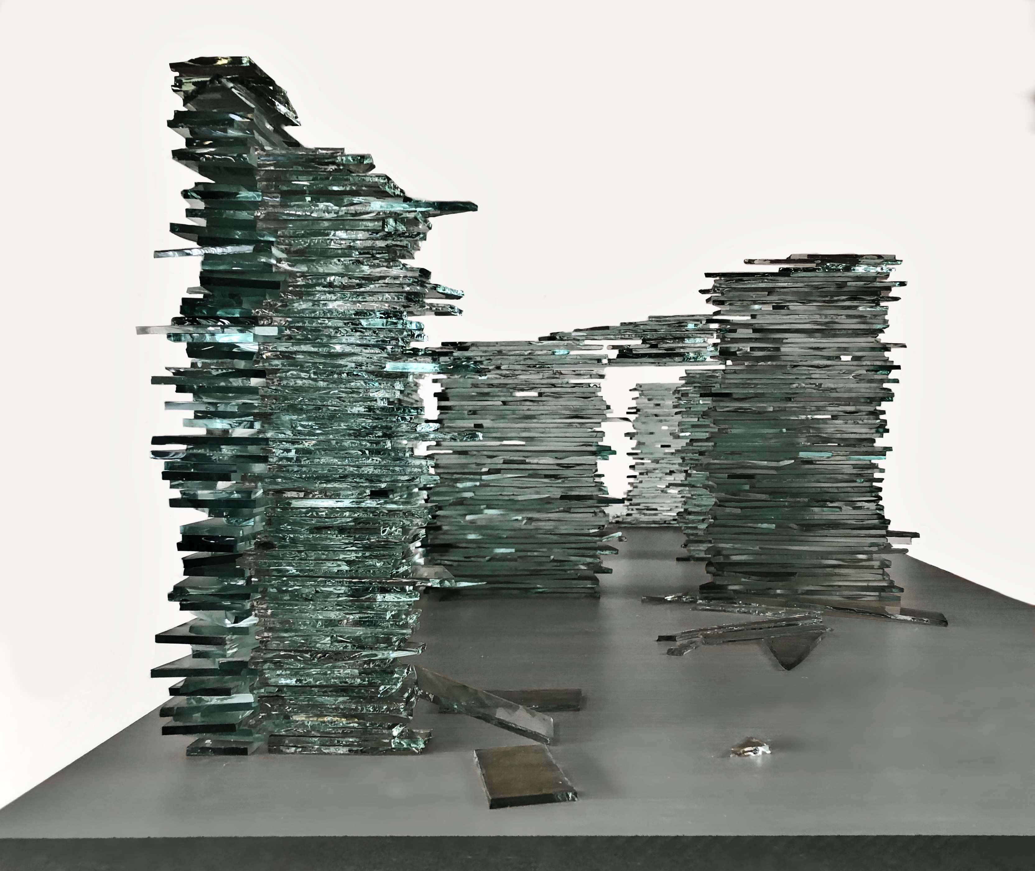

**Turan Aksoy**

***Dissymmetrical***

**14 November 2019 – 14 January 2020**

**Private View: Thursday 14 November,**

**6:30 – 8:30 pm**

*Untouchable, 100x60x50 cm, glass, 2019*

**Pi Artworks Istanbul is proud to host Turan Aksoy’s new solo show: *Dissymmetrical*. The artist builds the exhibition around the feeling of human solitude against extraordinary order and usual disorder of the world. *Dissymmetrical* will run between 14th November 2019 and 14th January 2020.**

*“What are we against a disorder befriending human solitude…*

*How slow and how lonely. For a world that doesn’t impose its existence…”*

Turan Aksoy’s new solo exhibition *Dissymmetrical* is based on the feelings of “slowness, stopping to look, waiting” that the artist thinks he has developed against time in recent years. The exhibition brings to viewers a selection of Aksoy’s works which translate these sensibilities into images of “isolated, desolated and devoiced world”.

Stating that time spent in Cyprus island in recent years has contributed to his understanding and interest toward “slowness and loneliness”; Aksoy describes the geography of the island as a place which wisely accompanies his sensibilities with its feelings of loneliness, sadness and disorder.

*Dissymmetrical*, referring to the names of the works in the exhibition, is described by Aksoy as; “Not so romantic memories of adolescence, an asymmetrical time extending with its reflection, looking at a static image for a long time, astonishment originating from fragility and immunity of the world, precious things determining life but abandoned in nowhere, and world leaving us alone with its extraordinary order and usual disorder.”

**Turan Aksoy. b. 1964, Turkey**. Works and lives between İstanbul and Kyrenia. Academic member of Arkin University of Creative Arts and Design. Selected solo exhibitions include; Not as You Think, O’Art, İstanbul, (2018); Hayali, Art Rooms Gallery, Kyrenia (2018); A Governable Paradise, Milli Reasurans Art Gallery, Istanbul (2015), A Portrait: Restless, Pi Artworks Istanbul, (2013); Dust and Rush, Pi Artworks Istanbul (2012); Glowing Thing, Pi Artworks Istanbul (2010); Marina Vista Contemporary Arts Platform, Mersin (2008); Bekleyen Unite, Roxy Event Platform, Istanbul (2007); Like a Dog, Siyah Beyaz Art Gallery, Ankara (2006); Emma, Me and Other Things, Kiplas Art Gallery, Istanbul (2006); Life, Cities, Women, Bibelot and Desktop Pictures, Helikon Art Gallery, Ankara (2006); Destansı Geçmiş, Belirsiz Gelecek, Apartment Project, Istanbul (2003); Ankara State Painting and Sculpture Exhibition, Ankara (2003).