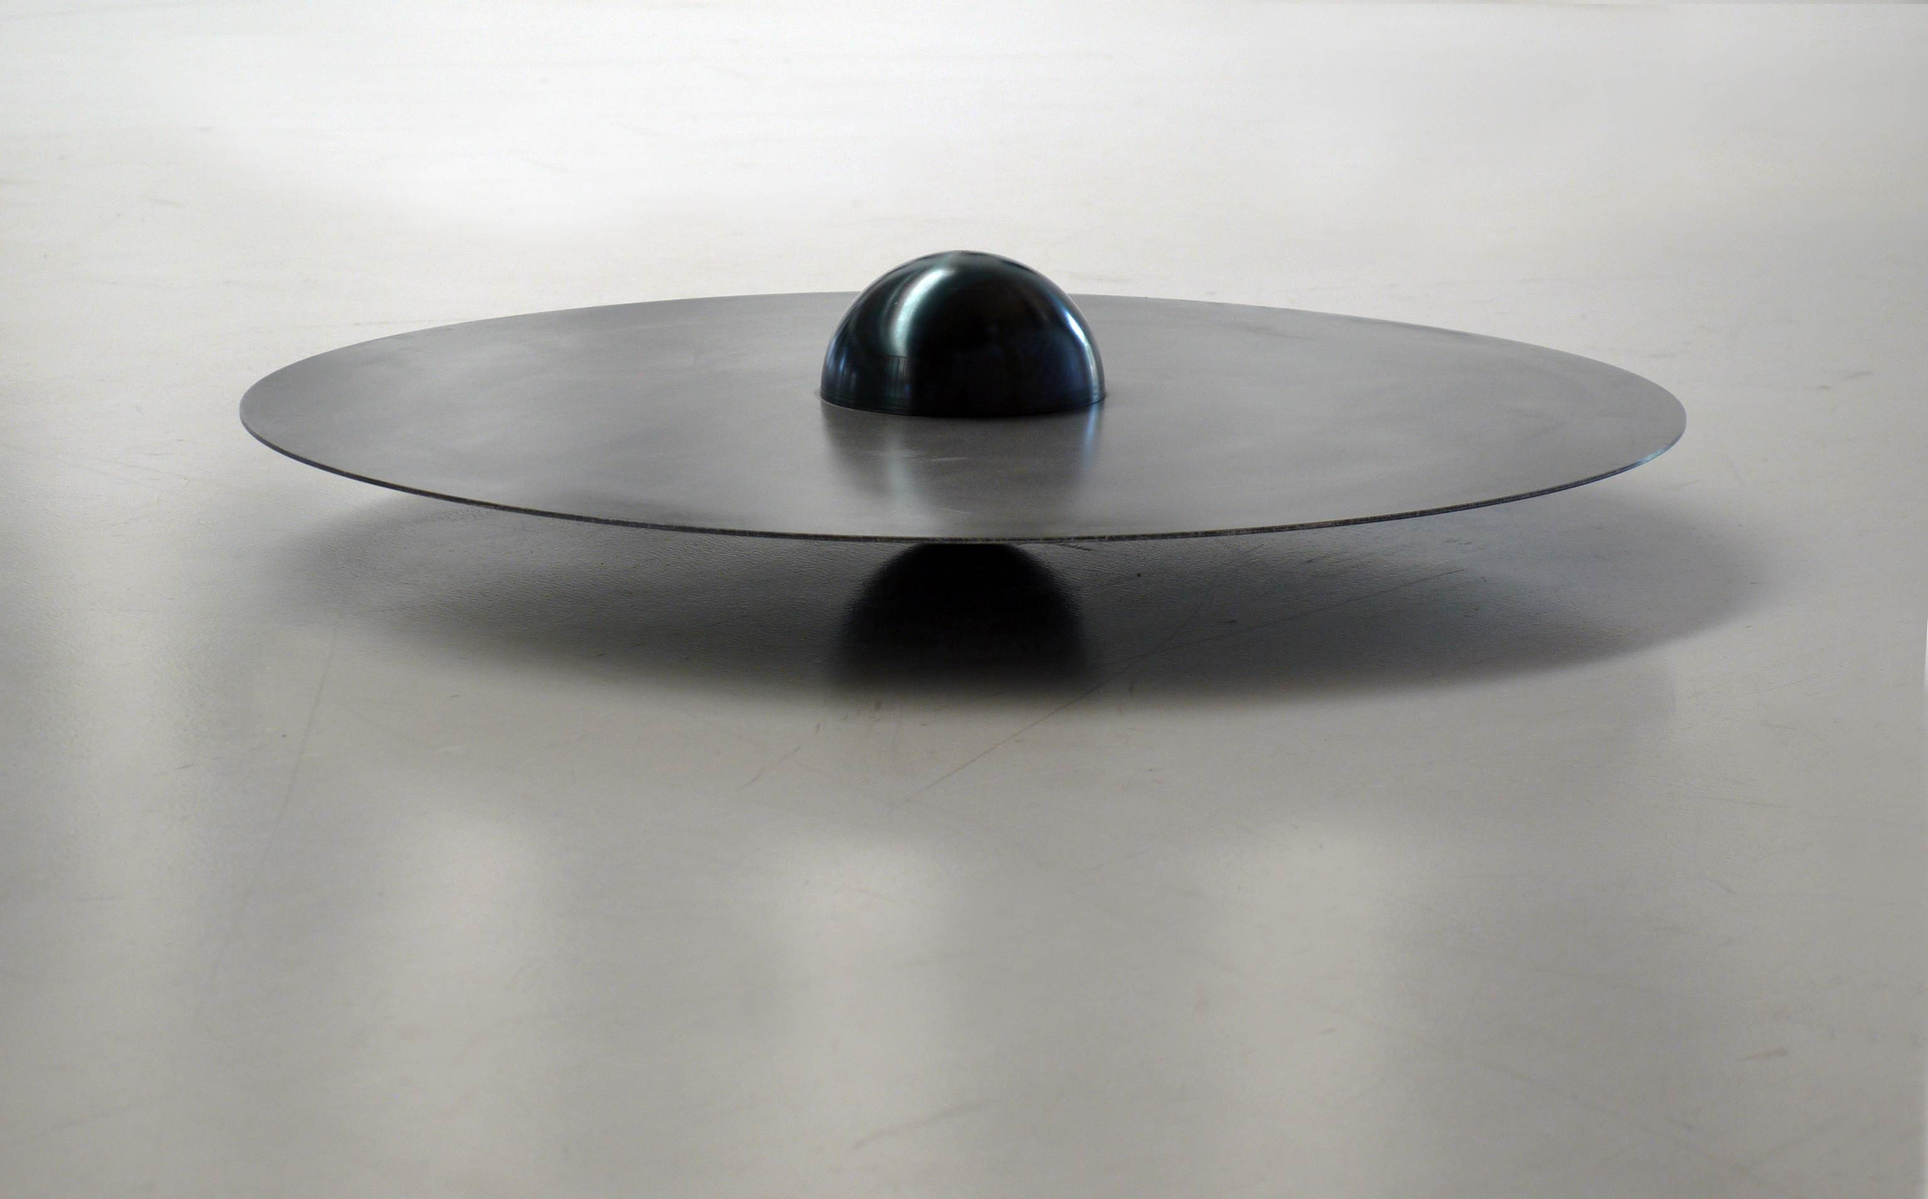Osman Dinc
Ankara-Istanbul

3-30 September 2019
MSGSÜ Tophane-i Amire
Culture and Art Center
Tek Kubbe
Private View: Tue., 3 Sep. 18:00 Saturn, steel, 21 x 100 cm, 2012

“Where I was born as an artist”, says Osman Dinc when he talks about Ankara. The exhibition Ankara-Istanbul brings together Dinc’s minimalist, abstract and Arte Povera inspired sculptures and photography works in a personal tribute to the city.

Osman Dinc’s Ankara-Istanbul exhibition is taking place at Tophane-i Amire Culture and Art Center, Tek Kubbe from 3rd to 30th of September. The exhibition is an opportunity to discover the international artist’s sculptures and photography works created in Ankara which he remembers as the place of his artistic rebirth.

Living and working in Paris since 1977, Osman Dinc keeps a privileged and warm place in his heart for Ankara for several personal reasons; as a young artist, the artist graduated from Gazi University Painting Department, a Bauhaus-influenced school at its establishment and offering multiple workshops on diverse material and technique. Now, an established artist, Dinc is in constant dialogue with young artists and art collectives in the city. Also, during his short trips to Turkey, Dinc produced his artworks in a studio situated in the center of Ostim Organized Industrial Region since the last twenty-nine years.

Osman Dinc, in addition of his studios in Paris and Orleans, has also a studio in the middle of the Ostim Organized Industrial Region. This 87 km² dystopian industrial area, which has transformed itself into an independent city inside of Ankara, contains more than six thousand industrial workshops, from various fields from electricity to medicine, of small or large scale, some of them highly advanced in technology. While Dinc meets his technical needs for the production of his artworks here, he is of course witnessing a thousand and one forms of metal, from work machine parts to steel bones for medical purpose.

The emotional association of this environment in question for the artist is exalted; Dinc, emerged in twisted time perception while living at a foreign country, is brought to past, to his memories of childhood and youth, beaten in a burning fire, to profession of forger -her mother’s family profession, to his memories at Bozkurt, Denizli, a village where mostly Balkan immigrants live, where forgers were working on horse-drawn carriage and plows; and also to the future; the

evolution of human history through metal, -the artist has made science illustrations to important encyclopedias for long years- to advanced science and technology, to an awareness of existing on a planet revolving around the Sun at a speed of one hundred thousand kilometers and in an infinite universe.

In this context, the Ankara-Istanbul exhibition presents the sculptures and photographs that the artist produced in the city during the last ten years, some of which were presented to the viewers at A World Story exhibition at CerModern, Ankara (2014). Osman Dinc’s minimalist, abstract and Arte Povera inspired sculptures stand out with their formal simplicity, they are described by himself as “an archeology of collective memory” and “a story of world” and are presented together with his photography works. According to Osman Dinc, both photography and sculpture are, in terms of forms, a matter of light; ““The sculpture explores the real place. The photo explores the imaginary space. A human being lives with both.”

Osman Dinc. b. 1948, Turkey, lives and works in Paris. Major exhibitions include; private collection show, Clermont-Ferrand, France, (August, 2020), Dessiner l'horizon (solo), Galerie Municipale Julio Gonzalez, Paris, Arcueil, France (2018); Beewax is the Elbow Grease of Bees (solo), Pi Artworks Istanbul, Turkey (2018); What's The Riddle, Pi Artworks London, UK (2016); A Story of the World (solo), CerModern, Ankara, Turkey (2014); Les Jeux De l'Eau Et du Miel, L'Agart, Amilly, France (2014); Theorem (solo), Pi Artworks Istanbul, Turkey (2014); Cosmic Touch, Espace Art Roch, Paris, France (2013); Logique de la Mappemonde, l'École Nationale Supérieure d'Art de Bourges, France (2013); and Out of Istanbul, Slought Foundation, Philadelphia, ABD (2008). Dinc has been the recipient of numerous awards, including the Ankara Art Foundation's Sculptor of the Year (2002), the UNESCO Sculptor of the Year (1993), and has been thrice awarded the State Museum of Turkey's Sculpture and Painting Award. Major collections include; Cirva Marseille, Marseille, France; The Art Collection of the Municipality of Paris, France; Istanbul Modern Museum, Turkey; Merkez Bank Collection, Turkey; The Annecy Museum Collection, France; and the State Museum of Sculpture and Painting, Ankara, Turkey.

For more information, images and sales:
Pi Artworks Istanbul & London
info@piartworks.com
ed@piartworks.com
Phone : +90 212 245 13 23
Adresse : Mumhane Cad. No: 50/3. 34425, Karaköy, Beyoğlu, İstanbul

